**Software Design Specification**

**The Software Design Specification Outline**

**1. Introduction**

This document provides documentation which will be used to aid in software development by providing the details for how the software should be built. Within the Software Design Document are narrative and graphical documentation of the software design for the project including sequence diagrams, state diagrams, class diagram and other supporting requirement information.

**1.1 Purpose of this document**

This Software Design Specification (SDS) provides an overview of the proposed Online Catering Management system project design.  It will encompass in detail the basic outline of our project and represent a basis for the development process.  This will also allow critical analysis of the logical and functional aspects of the design before any commitment is made to actual code.

**1.2 Scope of the development project**

The Catero website is intended to boost the sales of the catering company and create an efficient and sustainable business model of the company. The scope of the product is high because this catering company is already popular in its region and is willing to increase its online customers.

The purpose of the Catering management system is to create a convenient and easy-to-use application for customers, trying to book the orders. The system is based on a relational database with its Catering management. We will have a database server supporting to account all the orders and dates of events as well as we give important notifications. Above all, we hope to provide a comfortable user experience along with the best pricing available.

**1.3 Definitions, acronyms, and abbreviations**

IEEE: Institute of Electrical and Electronics Engineers

SDS: Software Design Specification

**1.4 References**

1.4.1 R. S. Pressman, Software Engineering: A Practioner’s Approach, 5th Ed, McGraw-Hill, 2001.

1.4.2 IEEE SDS template

**1.5 Overview of document**

This SDS is divided into seven sections with various sub-sections. The sections of the Software Design Document are:

1. Introduction: describes about the document, purpose, scope of development project definitions and abbreviations used in the document.
2. Conceptual Architecture: describes the overview of components, modules, structure and relationships and user interface issues.
3. Logical Architecture: describes Logical Architecture Description and Components.
4. Execution Architecture: defines the runtime environment, processes, deployment view.
5. Design Decisions and Trade-offs: describes the decisions taken along with the reason as to why they were chosen over other alternatives.

**2. Structure and relationships**

Make clear the interrelationships and dependencies among the various components. Structure charts can be useful here. A simple finite state machine can be useful in demonstrating the operation of the product. Include explanatory text to help the reader understand any charts.

**2.1. Admin’s side:**

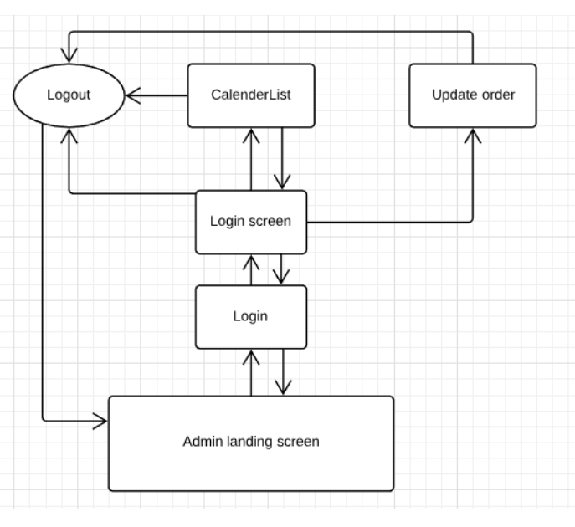

**2.2. User’s side:**

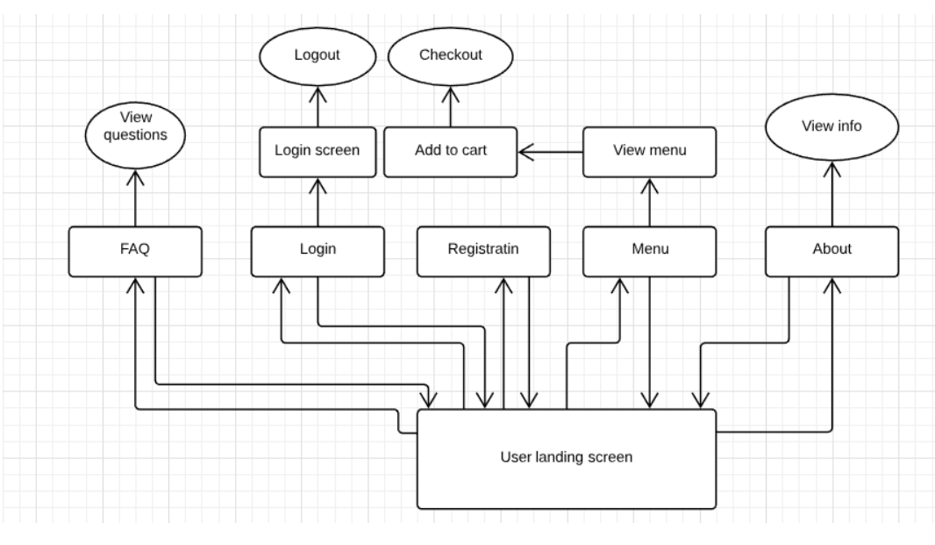

**2.3 User interface issues**

This section will address User Interface issues as they apply to the following hypothetical users of the Online Catering Management System (Catero).

* Let’s assume User A is well versed with using websites over internet. User also know English language. Catero will be using simple words like “Sign-In”, “Sign-Up”, “Feedback”, “Contact”, “Add to cart” etc.
* Let’s assume User B is an old person who isn’t versed with using internet, websites or any other such technology. If B want’s to place an order online he/she may ask someone to open the website and can place an order even through contacting the vendor. The contact information of vendor is given on the home page.

**3. Logical Architecture (Class Diagram, Sequence Diagram, State Diagram)**

**Class diagram:**

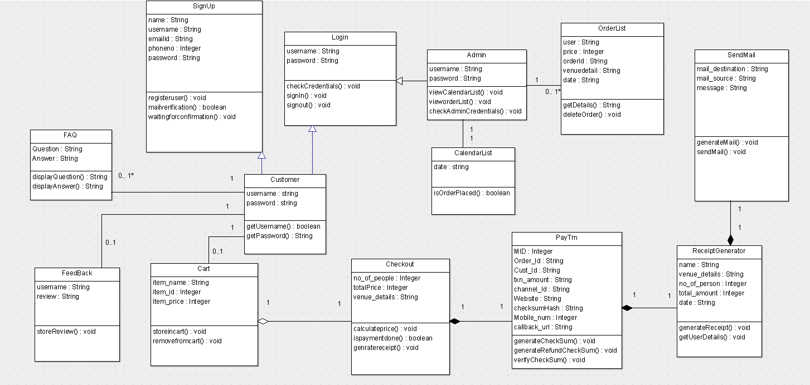

**Sequence diagram:**

**Sequence diagram: Login Page**

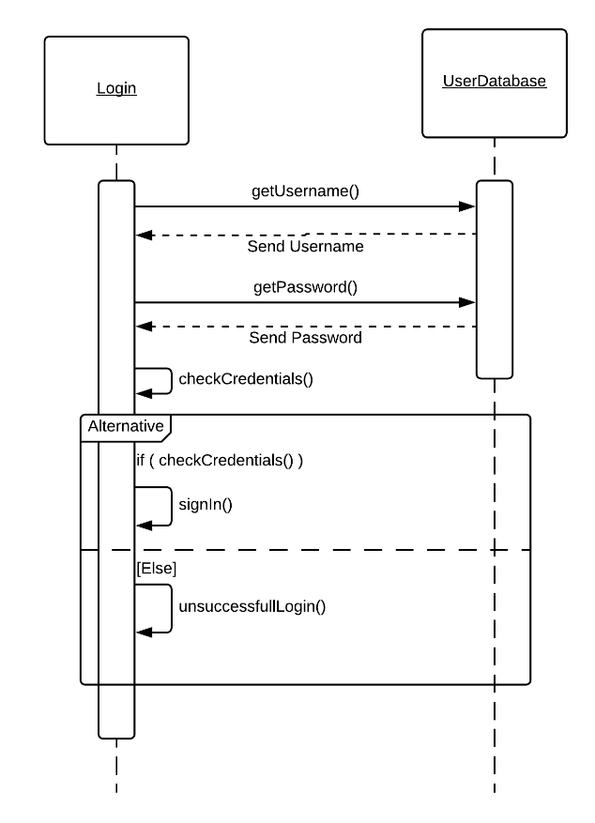

**Sequence diagram: Registration Page**

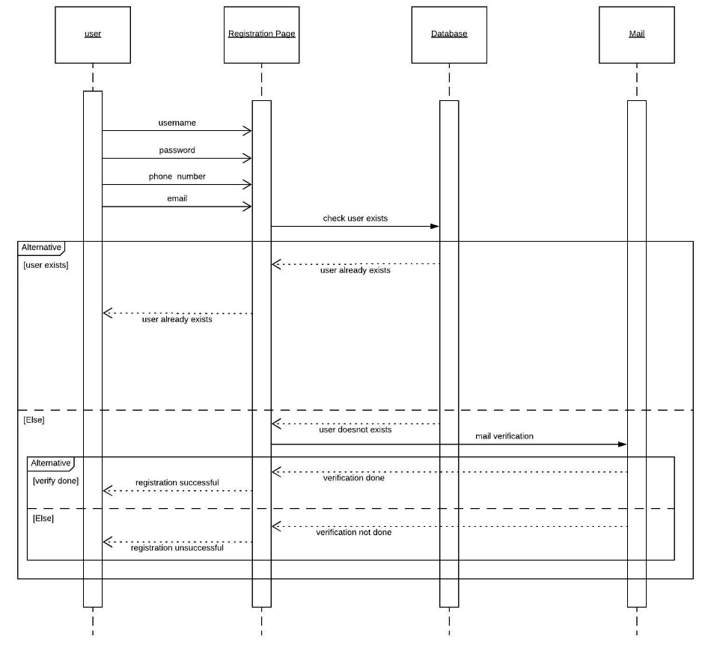

**Sequence diagram: FAQ Page**

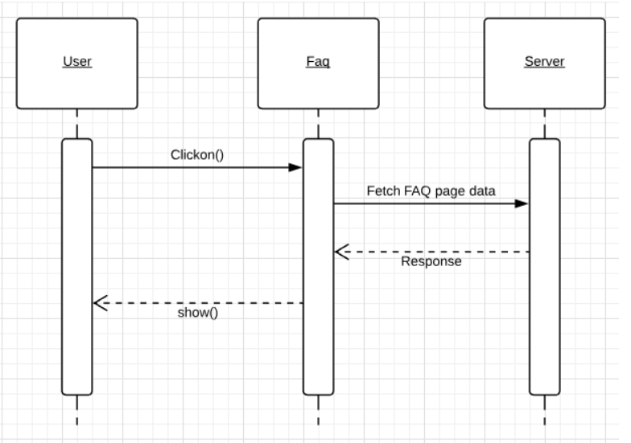

**Sequence diagram: Feedback Page**

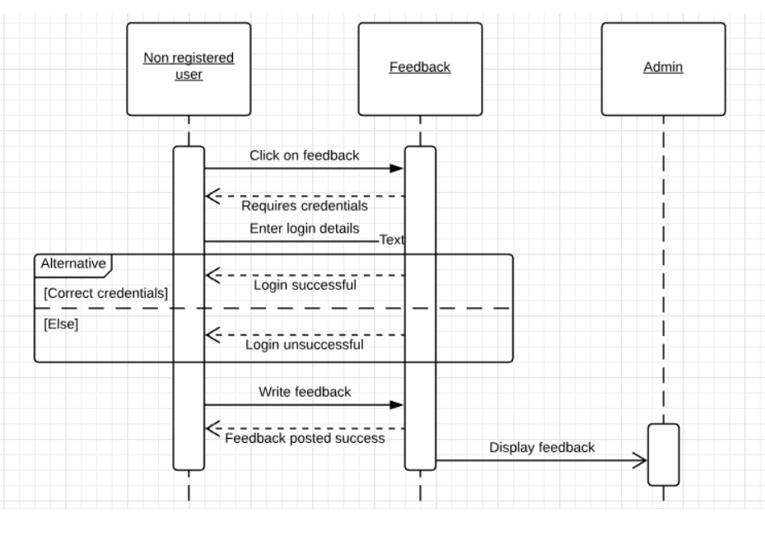

**Sequence diagram: About us**

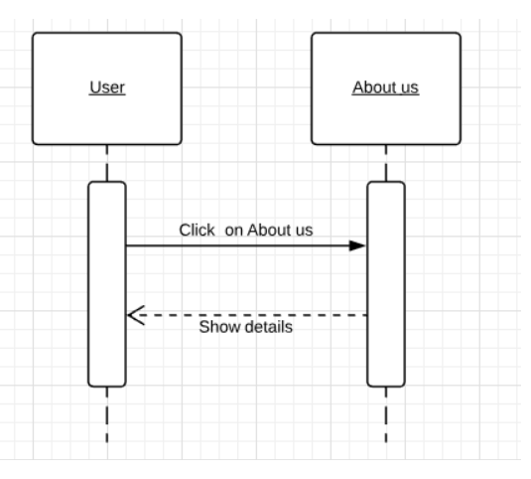

**Sequence diagram: Payment**

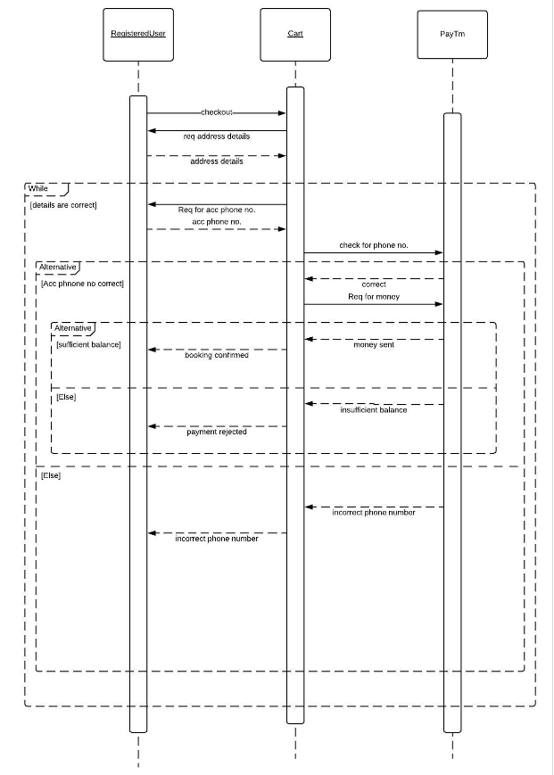

**Sequence diagram: Receipt Generator**

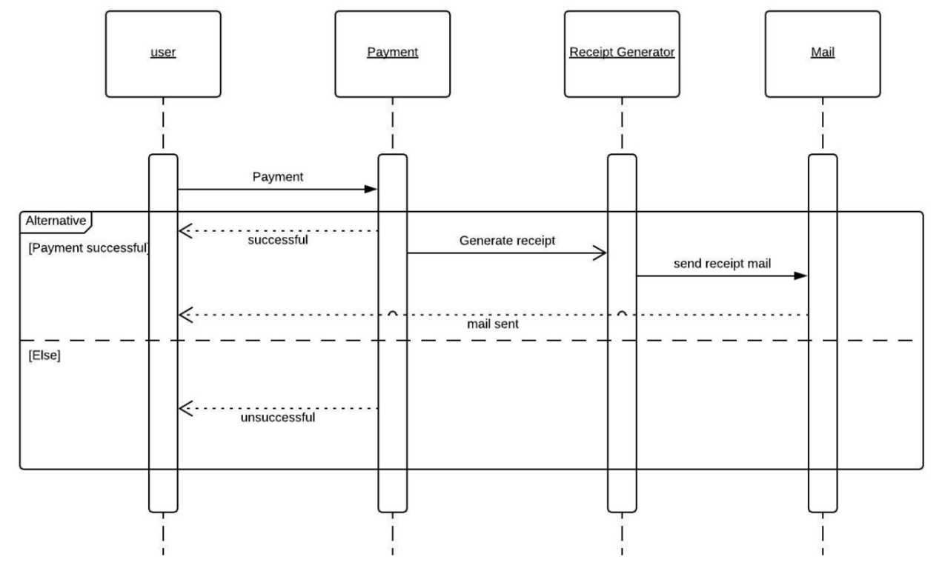

**Sequence diagram: Admin Order List**

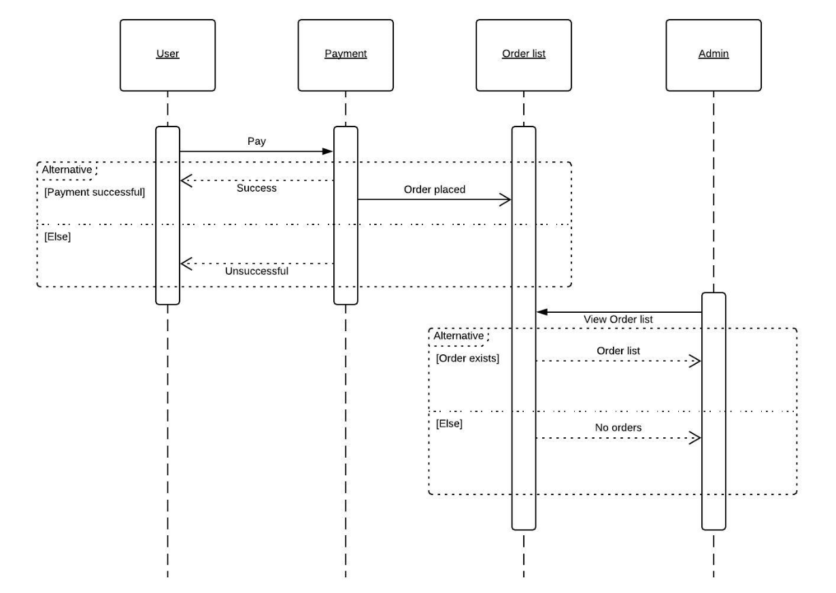

**State diagrams:**

**State diagram: Registration Page**

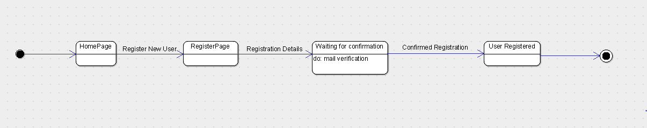

**State diagram: Login**

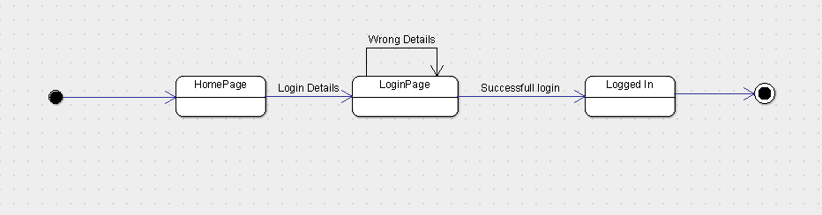

**State diagram: Gallery**

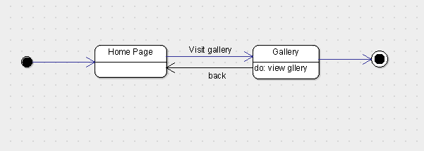

**State diagram: FAQ**

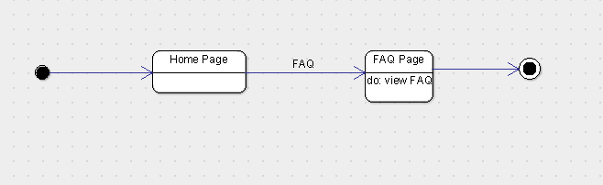

**State diagram: Feed back**

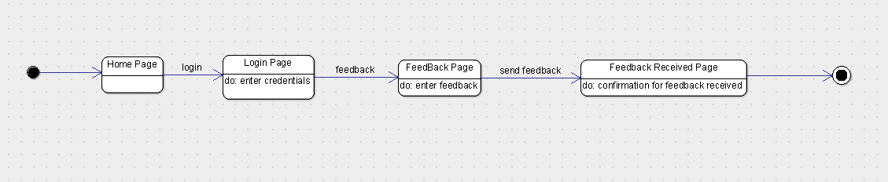

**State diagram: Sample Tasting**

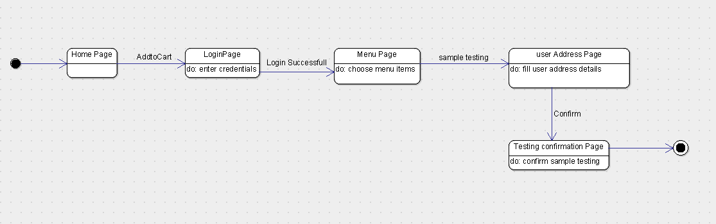

**State diagram: Place Order**

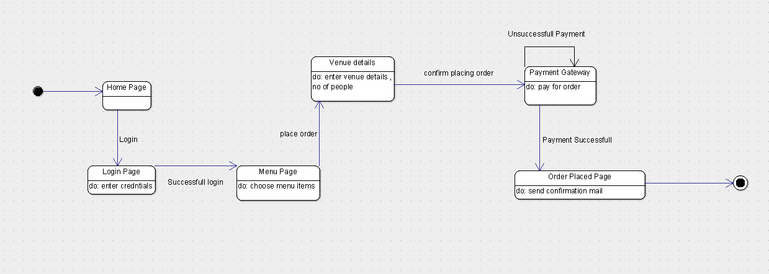

**State diagram: User’s Side (full)**

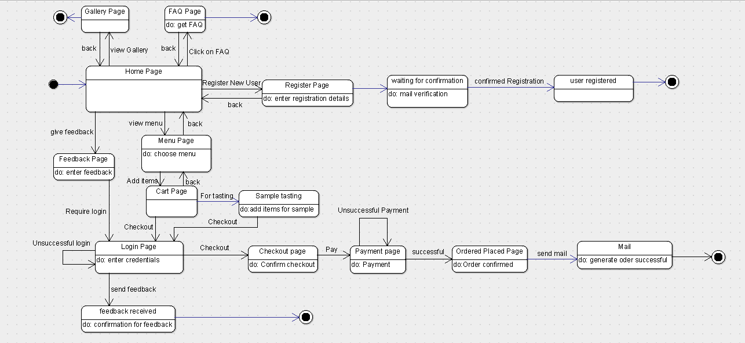

**State diagram: Admin Update Menu**

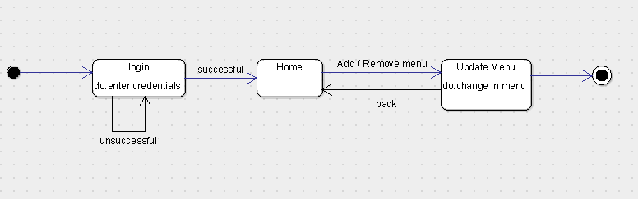

**State diagram: Admin Orders**

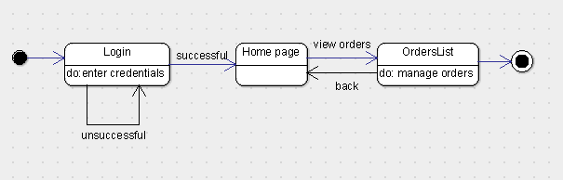

**State diagram: Admin Calendar’s List**

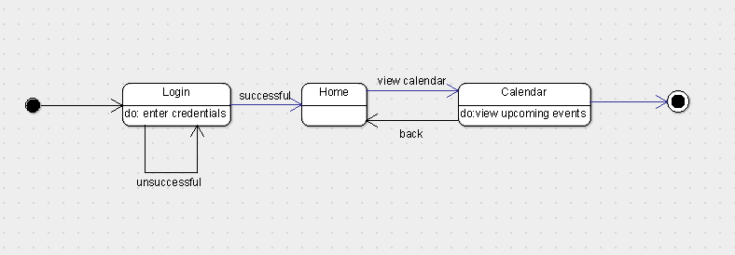

**State diagram: Admin’s Side (full)**

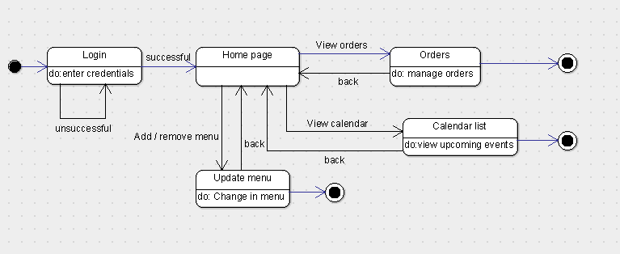

**3.1 Logical Architecture Description**

Discuss some details(generic) of Logical Architecture

**3.1.1. State Diagram**

Initial state is being shown by starting with a black dot. Final State is being shown by the black dot surrounded by an empty circle.

**3.1.3.1 Sign In:** On clicking the Sign In button on Home page, it lands on Login Page, which requires the input data from the user. Correct login credentials will lead the login to be successful making the user logged in for taking actions. Incorrect login credentials will redirect the user to same page with an error message.

**3.1.3.2 Sign Up:** On clicking the Sign Up button on Home page, it lands on Register Page, where the user has to input all the fields and click on register button. After the user has click on register button a link will be sent to the user’s mail account which on clicking will take the user to confirmation page where the user will be registered and confirm user for further operation’s onsite. If any field is left blank the user will be given prompt to fill the blank field.

**3.1.3.3 Sample Testing:** On clicking Menu button the user will be redirected to menu page where all the menu items are shown and user can select from given menu and add items to cart. Clicking on sample testing will lead to sign in page which if correctly done will lead to payment page for sample testing. After paying the payment for sample test the user is eligible for sample testing.

**3.1.3.4 Order Placing:** On clicking on Menu button the user will be redirected to menu page where all the menu items are shown and user can select from given menu and add items to cart. Clicking on checkout will lead to sign in page which if correctly done will lead to payment page for the order placed. After the payment is received by vendor the user will be given a prompt that his/her order has been placed. A mail with order receipt will be sent to user’s and vendor’s email id.

**3.1.3.5 FAQ:** On clicking on FAQ button on menu page it will redirect to FAQ page where some of the common questions of the users will be answered.

**3.1.3.5 Gallery:** On clicking on Gallery button on Menu page will redirect to Gallery page where some images are shown.

**3.1.3.6 Calendar List:** On clicking on sign in and after admin has been authorized he/she can see the list of events that will take place according to calendar.

**3.1.3.7 Update Order List:** After successful sign in the owner can update the order list which contains the deleting of order’s that has been completed or cancelled.

**3.1.3.8 Feedback:** Feedback option is available on home page. User will need to sign in first in order to give a feedback. After the submit button is clicked on feedback page the user will be given a prompt that his/her feedback has been recorded.

**3.1.2 Sequence Diagram :**

Arrow line signifies there is a send message taken place. Response is being shown by dotted arrows.

**3.1.2.1 Login Page:** It allows the users to login with their Username and password that are being registered in the database already. It loops being on same page until the correct information is not given.

**3.1.2.2 Admin orders:**

It allows the admin(owner) to view the orders list if they are present after user successfully completes payment and places order. If there are no orders present then order list without any orders(empty list) will be displayed.

**3.1.2.3 Receipt Generator:**

It is used to generate the receipt after the customer successfully makes payment. Then the generated receipt is sent through mail. If the successful payment is not done then receipt for the order will not be generated.

**3.1.2.4 Registration:**

Users will be able to register in the website with the register option available and after they are successfully registered their information is stored in the database so that the next time they enter the website there is no need to register again instead they can directly login.

**3.1.2.5 About us:**

It helps users to know information about the catering service provided and to know how the service operates and detailed information about the catering service.

**3.1.2.6 FAQ:**

FAQ’s are provided by the catering service to know how the service basically operates and information regarding how they manage the catering work allotted to them.

It may contain information about what are all the thing that to be informed to the catering service in prior to the event.

**3.1.2.7 Feedback:**

Feedback option is being provided which is used to share the experience of the clients with the catering service and is useful for the catering service to improve their customer satisfactory rate.

It is basically available for the users who are logged in and are genuine users which makes this function more reliable

**3.1.2.8 Payment:**

Payment option is available which allows users to pay the advance amount.

It can be done only by the registered user after adding items to the cart then heading toward checkout and providing the required details like venue address and phone number. The payment is processed based upon the items the user have chosen and is carried out through paytm gateway.

**3.2 Class name: Login**

**Description**: This class allows the user to enter the system by authenticating the entered credentials.

**3.2.1 Method 1:signIn()**

**Input:** SignIn through user name and password

**Output:** User landing page of login successful

**Method Description:**

This method allows user to login into Catero website with their user name and password. It redirects to CheckCredentials() method to verify the entered user name and password.

**3.2.2 Method 2: CheckCredentials()**

**Input:** user name and password

**Output:** Authentication of user name and password

**Method Description:**

This method checks whether the details entered by the user are correct or not. If the details entered are found incorrect it redirects the user back to the Sign In page.

**3.2.3 Method 3:signOut()**

**Input:** Click on Sign out button

**Output:** Landing to Home page after successful logout.

**Method Description:**

This method allows the user to log out of the catero website after the completion of placing the order.

**3.3 Class name: SignUp**

**Description**: This class allows the user to register in order to enter into the catero website.

**3.3.1 Method 1:registerUser()**

**Input:** name, user name, password, emailId, phone_no

**Output:** User landing page(Sign In) of registration successful.

**Method Description:**

This method allows user to register on Catero website with their name, user name, password, emailId and phone_no. After successful registration, user will be redirected to login page in order to make the booking of food.

**3.3.2 Method 2: waitingforconfirmation()**

**Input:** emailId, url

**Output:** Handles sending verification url to the user

**Method Description:**

This method is responsible for sending verification url to the user and waits for the user confirmation in order to successfully complete the Sign Up process of catero website.

**3.3.3 Method 3:mailVerification()**

**Input:** emailId, url

**Output:** Landing to Sign In page after successful verification.

**Method Description:**

This method checks whether the email confirmation is done by the user or not to complete the registration process.

**3.4 Class name: Feedback**

**Description**: This class is utilised for storing the feedback reviews provided by the customers who have utilised the services of the Catero.

**3.4.1 Method 1:storeReview()**

**Input:** user name, review

**Output:** Handles storing of review written by user.

**Method Description:**

This method allows user to give feedback of the services utilised and stores them so that the owner can view them and enhance the quality of the food being prepared.

**3.5 Class name: FAQ**

**Description**: This class is utilised for displaying frequently asked questions and apt answers for those questions.

**3.5.1 Method 1:displayQuestion()**

**Input:** click on FAQ button

**Output:** Launch the activity

**Method Description:**

This method allows user to view the frequently asked questions by the other users while ordering the catering services through Catero website.

**3.5.2 Method 1:displayAnswer()**

**Input:** click on FAQ button

**Output:** Launch the activity

**Method Description:**

This method allows user to view the answers to the frequently asked questions by the other users while ordering the catering services through Catero website.

**3.6 Class name: AddtoCart**

**Description**: This class allows the user to use all the functionalities regarding Shopping Cart.

**3.6.1 Method 1:additemtocart()**

**Input:** item_name, item_id, item_price

**Output:** Handles adding item to cart.

**Method Description:**

This method allows the user to add items into cart from the menu displayed. After adding the items to cart, user can view the cart and proceed to checkout.

**3.6.2 Method 2: storeincart()**

**Input:** item_name, item_id, item_price

**Output:** Handles storing the items added in cart

**Method Description:**

This method is responsible for storing the menu items added into the cart by the user. When the user clicks on the cart button, he will be displayed with all the items added into cart.

**3.6.3 Method 3:removefromcart()**

**Input:** item_name, item_id, item_price

**Output:** Handles removing the items from cart

**Method Description:**

This method allows the user to remove (or) delete the items added from cart.

**3.7 Class name: Checkout**

**Description**: This class contains methods that make the user to check out of the catero system.

**3.7.1 Method 1:calculateprice()**

**Input:** no_of_people, totalPrice,venue_details

**Output:** Handles the calculation of the total price to be paid .

**Method Description:**

This method calculates the total cost to be paid by the customer according to order placed per no_of_people, totalPrice of the menu selected and venue.

**3.7.2 Method 2: isPaymentdone()**

**Input:** no_of_people, totalPrice,venue_details

**Output:** Returns a boolean value regarding Payment done.

**Method Description:**

This method checks whether the payment is done or not by the customer.

**3.7.3 Method 3:generatereceipt()**

**Input:** no_of_people, totalPrice,venue_details

**Output:** Handles generation of receipt

**Method Description:**

This method is used for the generation of receipt after the payment is done by the customer.

**3.8 Class name: UserDatabase**

**Description**: This class is required for parsing through the User Database for login verification purpose.

**3.8.1 Method 1:getUsername()**

**Input:** username, password

**Output:** Handles the verification of Login credentials from database.

**Method Description:**

This method checks if the username entered is present in the usernames on the database.

**3.8.2 Method 2: getPassword()**

**Input:** username, password

**Output:** Handles the verification of Login credentials from database.

**Method Description:**

This method checks if the password entered matches with the username entered in the database.

**3.9 Class name: CalendarList**

**Description**: This class enables owner to view the calendar list of upcoming events sorted in date wise manner.

**3.9.1 Method 1: isOrderPlaced()**

**Input:** date

**Output:** Handles the creation of Calendar list of upcoming events.

**Method Description:**

This method is responsible for the creating Calendar list of upcoming events in date wise manner on owner side of the application.

**3.10 Class name: ReceiptGenerator**

**Description**: This class is responsible for the generation of Receipt after the order is placed by the user

**3.10.1 Method 1: getUserDetails()**

**Input:** no_of_people, totalPrice, venue_details, name, date

**Output:** Returns the order details of the user.

**Method Description:**

This method returns the booking details of the order placed by the user.

**3.10.2 Method 2:generatereceipt()**

**Input:** no_of_people, totalPrice, venue_details, name, date

**Output:** Handles generation of receipt

**Method Description:**

This method is used for the generation of receipt after the payment is done by the customer.

**3.11 Class name: SendMail**

**Description**: This class is responsible for sending of Receipt after the order is placed by the user through mail.

**3.11.1 Method 1: generateMail()**

**Input:** message

**Output:** Handles generation of mail content

**Method Description:**

This method is responsible for generating the mail to be sent to the user after the successful placing of order.

**3.11.2 Method 2:sendMail()**

**Input:** message, mail_source , mail_destination

**Output:** Handles sending of receipt through mail

**Method Description:**

This method is used for the sending the receipt generated through mail after the payment is done by the customer.

**3.12 Class name: OrderList**

**Description**: This class is responsible for generating the order details after the order is successfully placed.

**3.12.1 Method 1: getUsername()**

**Input:** user, price, orderplaced, venuedetails, date

**Output:** Handles generation of user details

**Method Description:**

This method is responsible for generating the user details of the order placed.

**3.12.2 Method 2:getPrice()**

**Input:** user, price, orderplaced, venuedetails, date

**Output:** Handles generation of total price

**Method Description:**

This method is used for getting the total price of order placed.

**3.12.3 Method 3:getOrderPlaced()**

**Input:** user, price, orderplaced, venuedetails, date

**Output:** Handles getting placed orders

**Method Description:**

This method is used for getting the details of placed orders.

**3.12.4 Method 4:getVenuedetails()**

**Input:** user, price, orderplaced, venuedetails, date

**Output:** Handles generation of venue to be delivered at for the placed order

**Method Description:**

This method is used for getting the delivery details of the location where food should be delivered.

**3.12.5 Method 5:getDate()**

**Input:** user, price, orderplaced, venuedetails, date

**Output:** Handles generation of date of the order placed

**Method Description:**

This method is used for getting the date of the order placed in order to sort all the orders in date wise manner.

**3.12.6 Method 6:deleteOrder()**

**Input:** user, price, orderplaced, venuedetails, date

**Output:** Handles deleting the order

**Method Description:**

This method is used for the deletion of orders by the owner which are already delivered.

**3.12.7 Method 7:viewPlacedOrder()**

**Input:** user, price, orderplaced, venuedetails, date

**Output:** Launch the activity

**Method Description:**

This method is used for viewing all the placed orders on owner side of the application.

**3.13 Class name: PayTm**

**Description**: This class is responsible for payment through PayTm.

**3.13.1 Method 1: generateCheckSum()**

**Input:** M_id, order_id, cust_id, Txn_amt, channel_id, website, checkSumHash, mobile_no

**Output:** Handles payment through PayTm

**Method Description:**

This method is responsible for generating checksum to be sent for Paytm server.

**3.13.2 Method 2:generateRefundCheckSum()**

**Input: Input:** M_id, order_id, cust_id, Txn_amt, channel_id, website, checkSumHash, mobile_no

**Output:** Handles payment through PayTm

**Method Description:**

This method is used for getting the response from the paytm server.

**3.13.3 Method 3:verifyCheckSum()**

**Input: Input:** M_id, order_id, cust_id, Txn_amt, channel_id, website, checkSumHash, mobile_no

**Output:** Handles payment through PayTm

**Method Description:**

This method is used for the verification of the checksum generated.

**3.14. Admin:**

This class is responsible for logging of admin and some of the admin actions.

3.14.1. Method 1: checkAdminCredentials()

Input: None

Output: None

Description: This Method checks admin credentials so that admin can login.

3.1.32 Method 2: viewCalendarList()

Input: None

Output: None

Description: This method is responsible for showing upcoming events to admin via notification on Calendar on Admin dashboard.

3.1.33 Method 3: viewOrderList()

Input: None

Output: None.

Description: This method is responsible for showing all the Placed Order to admin.

**4.0 Execution Architecture**

Runtime environment required is any device like Laptop/Mobile which can open web browser having active internet connection, Eclipse as a deployment platform.

**4.1 Reuse and relationships to other products**

NIL

**5.0 Design decisions and tradeoffs**

The design decision to use two layouts separately for admin and for customers is to provide encapsulation. It may have been possible to get all the information on one screen. However, using two screens will keep the data of admin separate from the data being accessed by Cusomers.

**6.0 Pseudocode for components**

**Login Page**

**Pseudo-Code:**

Input: email,password

Output: Redirects to Home Page after successful login

1. protected void doPost(HttpServletRequest request, HttpServletResponse response) {
2. String u = get EmailId from HTML page
3. String p = get Password from HTML page
4. Mydao md = new Mydao(); creates an object md of Mydao class
5. TRY
6. String name = md.CustomerLogin(u, p);
7. IF name not equal to null then
8. Redirect to index.jsp
9. ELSE
10. RequestDispatcher rd = Dispatches the current page to index.jsp
11. request.setAttribute("msg", "Login Fail,try again");
12. forwards the request to index.jsp file
13. END ELSE
14. END IF
15. CATCH Handles exception

**Register Class**

**Pseudo-Code:**

Input: FirstName, LastName, Gender, EmailId, mobileno, password

Output: Redirects to Login Page after successful Registration

1. protected void doPost(HttpServletRequest request, HttpServletRespons e response) {
2. String firstname=get FirstName from HTML page
3. String lastname=get LastName from HTML page
4. String gender=get Gender from HTML page
5. String emailid=get Email_id from HTML page
6. String mobileno=get MobileNo from HTML page
7. String password=get Password from HTML page
8. customerbean e=new customerbean(); Creates object e of customerbean class
9. e.setFirstname(firstname); sets the firstname of customer
10. e.setLastname(lastname); sets the lastname of customer
11. e.setGender(gender); sets the gender of customer
12. e.setEmailid(emailid); sets the emailid of customer
13. e.setMobileno(mobileno); sets the mobileno of customer
14. e.setPassword(password); sets the password of customer
15. Mydao m=new Mydao(); creates object for dao class
16. initializes x=m.insertCustomer(e);
17. IF x not equal to 0 then
18. RequestDispatcher rd=dispatches request to login.jsp
19. Sets the msg attribute with value Account Created...
20. rd.forward(request, response);
21. END IF

**Admin Login**

**Pseudo-Code:**

Input: uid,pwd

Output: Redirects to Admin Home Page after successful login

1. protected void doPost(HttpServletRequest request, HttpServletResponse response){
2. PrintWriter out = response.getWriter();
3. String u =get uid from HTML page
4. String p = get pwd from HTML page
5. Mydao md = new Mydao();
6. Initialize x = md.AdminLogin(u, p);
7. IF x not equal to 0 then
8. HttpSession session = request.getSession(); Creates a session for the user
9. session.setAttribute("user", u); User submitted is set in the session
10. redirect response to AdminHomePage.jsp
11. END IF
12. ELSE
13. RequestDispatcher rd = dispatch request to Index.jsp
14. sets the msg attribute with value Login Fail,try again
15. rd.forward(request, response); forwards to index.jsp file
16. END ELSE
17. }

**Add to Cart**

**Pseudo-Code:**

Input: pid,price,quantity

Output: Adds the selected product to cart

1. protected void doGet(HttpServletRequest request, HttpServletResponse response) throws ServletException, IOException {
2. String pid, price, quantity = get pid, price, quantity from HTML page
3. initialize ip to null
4. HttpSession hs=request.getSession();Creates a session for the user
5. String user=get FirstName from HTML page
6. IF(user==null)
7. ip=new Mydao().ipAdd();
8. int x=new Mydao().addtocart(pid,quantity,ip);
9. IF x not equal to 0 then
10. Make ArrayList<addproductbean> object(list) = new Mydao().ViewAllProduct();
11. RequestDispatcher rd= Dispatches to shopss.jsp
12. sets the msg attribute with value item added to cart
13. request.setAttribute("data", list);
14. rd.forward(request,response); ); forwards shopss.jsp file
15. END IF
16. ELSE
17. initializes x=new Mydao().addtocart(pid,quantity,user);
18. IF x =! 0 then
19. Make ArrayList<addproductbean>object( list) = new Mydao().ViewAllProduct();
20. RequestDispatcher rd= Dispatches to shopss.jsp
21. request.setAttribute("msg", "item added to cart");
22. request.setAttribute("data", list); Sets the data attribute with list
23. forwards request to shopss.jsp file
24. END IF
25. END ELSE
26. END IF

**Place Order**

**Pseudo-Code:**

Input: FirstName, user,amount

Output: Redirects to OrderMail upon successful placing of order

1. **protected** **void** doGet(HttpServletRequest request, HttpServletResponse response) **throws** ServletException, IOException {
2. HttpSession hs=request.getSession();
3. String user = get FirstName from HTML page;
4. String Emailid= get user from HTML page;
5. **long** id=System.*currentTimeMillis*();
6. String orderid="Od-Id"+(id+"").substring(5);
7. get amount from HTML page
8. **double** amount=Double.*parseDouble*(request.getParameter("amount"));
9. **initialize** x=**new** Mydao().placeOrder(user,amount,orderid);
10. IF x =! 0 then
11. RequestDispatcher rd=Dispatch to ordermail
12. request.setAttribute("Emailid", Emailid); Sets the Emailid attribute
13. request.setAttribute("orderid", orderid); Sets the orderid attribute
14. request.setAttribute("FirstName",user); Sets the FirstName attribute
15. forwards request to ordermail
16. END IF
17. }

**Check Email**

**Pseudo-Code:**

Input: id

Output: checks if the email already exists or not

1. **protected** **void** doPost(HttpServletRequest request, HttpServletResponse response) **throws** ServletException, IOException {
2. PrintWriter out=response.getWriter(); creates Print writer object out
3. String email = request to get **id** from HTML page
4. String m=checkEmail(email); stores the returned value by calling the checkEmail method
5. out.println(m); Already exist or available
6. }
7. **public** String checkEmail(String email)
8. {
9. Initializes msg to null
   1. **TRY**
   2. {
      1. Initializes x to 0
      2. Class.*forName*("com.mysql.jdbc.Driver");
      3. con=DriverManager.*getConnection*("jdbc:mysql://127.0.0.1:3306/zappy", "root", "lohith@123"); Create database connection
      4. String sql = "select * from customerdetails where Emailid=?"; sql query to select all details of a particular customer
      5. PreparedStatement ps = con.prepareStatement(sql);
      6. ps.setString(1, email);
      7. ResultSet rs = ps.executeQuery(); Execute statement query
      8. **WHILE**(rs.next())

X=1;

* + 1. **IF** x = 1 then

msg="<font color=red>Already Exist</font>";

* + 1. **ELSE**

msg="<font color=green>Avaliable</font>";

* 1. **Catch** handles Exception

1. return msg;
2. }
3. }

**Show Cart**

**Pseudo-Code:**

Input: FirstName

Output: Displays the cart

1. **protected** **void** doGet(HttpServletRequest request, HttpServletResponse response) **throws** ServletException, IOException {
   * 1. **initialize** ip, user to n**ull**;
     2. **initialize** count=0;
     3. HttpSession hs= request.getSession(); creates session request
     4. String userid=(String)hs.getAttribute("FirstName");
     5. **IF**(userid==**null**)

ip=**new** Mydao().ipAdd();

* + 1. **ELSE**
    2. ip=userid

1. Make ArrayList<addproductbean> object(list) = **new** Mydao().showCart(ip);
2. count=**new** Mydao().count(user);
3. **IF** list not equal to null then
   1. RequestDispatcher rd=dispatches cart.jsp
   2. request.setAttribute("ip", ip); sets ip attribute
   3. request.setAttribute("data", list); sets data attribute to list
   4. request.setAttribute("count", count); sets count attribute
   5. rd.forward(request, response); forwards to cart page
4. END IF
5. **ELSE**
   1. RequestDispatcher rd=Dispatches cart.jsp
   2. Sets the msg to your cart is Empty
   3. rd.forward(request, response); forwards to another cart file
6. END ELSE

}

**Show Product**

**Pseudo-Code:**

Input: None

Output: Displays the Menu Items

1. **protected** **void** doGet(HttpServletRequest request, HttpServletResponse response) **throws** ServletException, IOException {
2. Make ArrayList<addproductbean> object(list) = **new** Mydao().ViewAllProduct();
3. RequestDispatcher rd=Dispatches shopss.jsp
4. sets data attribute to list
5. forwards the request to shopss.jsp file
6. }

**View Product**

**Pseudo-Code:**

Input: None

Output: redirects to viewallproducts.jsp file

1. **protected** **void** doGet(HttpServletRequest request, HttpServletResponse response) **throws** ServletException, IOException {
2. Make ArrayList<addproductbean> object(list) to Mydao().ViewAllProduct();
3. RequestDispatcher rd= Dispatches to viewallproduct.jsp
4. sets data attribute value to list
5. rd.forward(request, response); forwards to another viewallproducts page
6. }

**View Product Desciption**

**Pseudo-Code:**

 Input: pid

Output: displays the description of the product

1. **protected** **void** doPost(HttpServletRequest request, HttpServletResponse response) **throws** ServletException, IOException {
2. **int** p= get pid from HTML page
3. Make ArrayList<addproductbean> object(list) to new Mydao().singleproduct(p);
4. **IF** list not equal to null then
5. RequestDispatcher rd=Dispatches to single.jsp
6. request.setAttribute("data", list); sets data attribute value to list
7. rd.forward(request, response);
8. END IF
9. }

**Remove from cart**

**Pseudo-Code:**

Input: pid, FirstName

Output: Removes the selected product from cart

1. **protected** **void** doGet(HttpServletRequest request, HttpServletResponse response) **throws** ServletException, IOException {
2. HttpSession hs = Retrive seesion object
3. String pid = get pid from HTML page
4. String user = get FirstName from HTML page
5. **IF** list not equal to null then
6. **Initialize** x = **new** Mydao().remove(pid, user);
   1. **IF** x =! null then
   2. Redirect to ShowCart
   3. **else**
   4. Redirect to ShowCart
   5. **else**
   6. String ip = **new** Mydao().ipAdd();
   7. **initializes** x = **new** Mydao().remove(pid, ip);
7. **IF** not equal to null then
   1. Redirect to ShowCart
8. **else**
   1. Redirect to ShowCart
      1. }
9. }

**Order Placed**

**Pseudo-Code:**

Input: None

Output: Displays the placed orders to the owner

1. **protected** **void** doGet(HttpServletRequest request, HttpServletResponse response) **throws** ServletException, IOException {
2. PrintWriter out=response.getWriter();
3. HttpSession hs=get session object
4. String user= get FirstName from HTML page
5. Make object of ArrayList<ordertable> o= **new** Mydao().DetailAfterPlacingOrder(user);
6. **IF** o != null then
   1. RequestDispatcher rd= Dispatches to OrderPlaced.jsp
   2. Sets data attribute to o
   3. rd.forward(request, response); forwards the request
7. END IF
8. **ELSE**

out.println("error");

1. END ELSE
2. }

**Logout**

**Pseudo-Code:**

Input: none

Output: Invalidates the session and redirects to home page

1. **protected** **void** doGet(HttpServletRequest request, HttpServletResponse response) **throws** ServletException, IOException {
2. HttpSession session=request.getSession(); creates session object
3. now clearing the session object
4. session.invalidate(); it logouts the account
5. response.addHeader("pragma", "no-cache");
6. response.addHeader("cache-control", "no-store");
7. response.addHeader("expire", "0"); expires the session immediately
8. returing to home page
9. RequestDispatcher rd = Dispatches to index.jsp
10. rd.forward(request, response); forward to another jsp file
11. }

**ForgotPassword**

**Pseudo-Code:**

Input: EmailId

Output: New password is sent to the entered EmailId

1. **protected** **void** doGet(HttpServletRequest request, HttpServletResponse response) **throws** ServletException, IOException {
2. email = get email_id from HTML page
3. pass = **new** Mydao().ForgetPassword(email);
4. **if** pass not equal to null then
   * 1. to = email; sends email to particular customer
     2. msg = some suitable message with username
     3. from = "catero@gmail.com"; Sender's email ID needs to be mentioned
     4. **final** String username, password = XXXX; "XXXX" signifies user details
     5. host = creates host
     6. Properties props = **new** Properties();
     7. props enables auth, host and sets port number
     8. Session session = Session.*getInstance*(props, **new** javax.mail.Authenticator() {
     9. **protected** PasswordAuthentication getPasswordAuthentication() {
     10. **return** **new** PasswordAuthentication(username, password);
5. END IF
6. });
7. t**ry** block
   * 1. Message message = **new** MimeMessage(session);
     2. Message obj sets from, recipients, subject, text
     3. Transports the message
     4. Sets msg attribute to “Your Password Has Been Sent” and Dispatches login.jsp
8. **catch** handles messaging exception
9. **ELSE**

sets msg to Email Id does not exsist

1. END ELSE
2. }

**Add Product**

**Pseudo-Code:**

Input: productname,category,productprice,weight,description,image

Output: Adds products to the menu

1. **protected** **void** doPost(HttpServletRequest request, HttpServletResponse response) **throws** ServletException, IOException {
2. Initiliazes productname, category, productprice, weight, description, image =**null**;
3. **boolean** isMultipart = ServletFileUpload.*isMultipartContent*(request);
4. **if** !isMultipart then
5. **return**;
6. Make factory obj for DiskFileItemFactory
7. Sets threshold size and upload size to max
8. **try** then
9. List fileItems = upload.parseRequest(request);
10. Iterator i = fileItems.iterator();
    1. **while** ( i.hasNext())
       1. {
       2. FileItem fi = (FileItem)i.next();
       3. **if** fi.isFormField () then

Checks for productname, category, productprice, weight, description

* + 1. else
       1. {
       2. String fieldName = fi.getFieldName();
          1. **If** fieldName.equals("ima") then
          2. Makes servlet config object sc
          3. image=fi.getName();
    2. File f = **new** File(sc.getServletContext().getRealPath("/")+"imagesap") ; Makes file obj
       1. **If** !f.exists() then
          1. f.mkdir();
    3. File = **new** File(sc.getServletContext().getRealPath("/")+"imagesap/"+image) ;
       - 1. fi.write( file ) ;
         2. out.println("Uploaded Filename: " +image + "<br>");
         3. System.***out***.println("PATH="+file.getPath());
  1. END WHILE
     1. END IF
     2. END ELSE
     3. END IF

1. **catch** Handles exception
2. addproductbean e=**new** addproductbean();
3. e object adds the productname category productprice weight description image
4. Mydao m=**new** Mydao(); creates database object m
5. Adds the product in the database and displays Product added
6. }
7. }

**Delete Product**

**Pseudo-Code:**

Input: productname

Output: Selected product is deleted and displays all available products

1. **protected** **void** doGet(HttpServletRequest request, HttpServletResponse response) **throws** ServletException, IOException {
2. PrintWriter out=response.getWriter(); creates writer object out
3. String acn=request.getParameter("productname"); Gets product name
4. **try** block
   1. Register the database driver by using
   2. Class.*forName*("com.mysql.jdbc.Driver");
   3. Create database connection
   4. Connection con=DriverManager.*getConnection*("jdbc:mysql://127.0.0.1:3306/zappy", "root", "lohith@123");
5. Deletes product name from the database
6. PreparedStatement ps=con.prepareStatement("delete from addproduct where productname=?");
7. ps.setString(1, acn);
8. Execute statement query ps.executeUpdate();
   1. **if** x not equal to null then
      1. RequestDispatcher rd=Dispatches to viewallproduct.jsp
      2. Make ArrayList<addproductbean>object( list) for ViewAllProduct();
      3. Set data value attribute to list
      4. request.setAttribute("msg", "Product Deleted of ProductName is = "+acn);
      5. forwards the request to view all products page
   2. END IF
9. con.close();
10. END TRY
11. **Catch Handles e**xception
12. }

**OrderMail**

**Pseudo-Code:**

Input: EmailId, FirstName, oid

Output: Order Confirmation message is sent to user mail

1. **protected** **void** doGet(HttpServletRequest request, HttpServletResponse response) **throws** ServletException, IOException {
2. String to = gets email id of recipient
3. String sub="Order Confirmation";
4. String name=gets first name
5. String Oid= gets orderid
6. String msg= sends order placed message to the customer
7. String from = Sender's email ID needs to be mentioned
8. **final** String username = username to be mentioned
9. **final** String password = password of sender
10. String host = mention host name
11. Properties props = **new** Properties();
12. props enables auth, host and sets port number
13. Make Session object(session) = Session.*getInstance*(props, **new** javax.mail.Authenticator() {
14. **protected** PasswordAuthentication getPasswordAuthentication() {
15. **return** **new** PasswordAuthentication(username, password);
16. }
17. });
18. **try** block
    * 1. Message message = **new** MimeMessage(session);
      2. Message obj sets from, recipients, subject, text
      3. Transports the message to recipient
      4. PrintWriter out=response.getWriter(); creates writer object
      5. Displays message sent successfully
      6. Redirects to Orderplaced
19. END TRY

**catch** Handles exception

}

**7.0 Appendices (if any)**

**NIL**